North Dakota SARE Professional Development Support Program

A Professional Development Program Sponsored by:

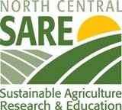 And

Program Overview
Sustainable agriculture is about building the best food and fiber systems that we can by integrating the goals that help enhance Quality of Life, the Environment and Economics.
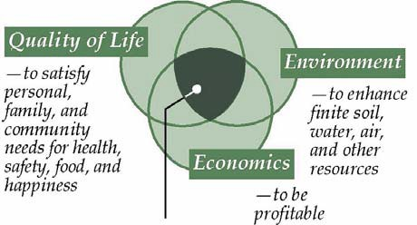
Food production systems that are likely to remain productive and sustainable are the ones that meet all three of these major goals.

To help educate North Dakota citizens about these integrated goals, the North Dakota SARE professional development program will support educators with Extension, Vo-Ag, other Governmental and Tribal Agencies, Lending Institutions, Agribusiness, and Non-Governmental Organizations to attend or conduct field days, farm tours, workshops, etc. Recipients are expected to attend or conduct educational programs with a focus on sustainable food and fiber issues and to report these activities to the North Dakota SARE program.
Examples could include; SARE supported winter conferences, soil health education events, the Tribal College/NDSU Horticulture Tour, the NACAA national conference, and travel to other worthy sustainable agriculture professional development opportunities. Travel related funds can be used for mileage, meals, lodging and registration expenses by educators who can demonstrate the need for the information and a plan to deliver it. Event support funds can be used for educational materials, speaker fees, meals (only if concurrent within the meeting), and other related expenses. For reimbursement, recipients will need to fill out a short summary form, take the National SARE basic principles course and later fill out a brief survey several months after the event to describe the educational outcomes.
The application is attached. Feel free to expand the length to fit in your answers, especially if you intend to write into the spaces by hand. Please also attach the meeting agenda and SARE course verification.

2012 North Dakota SARE Professional Development Application

Name:
Phone and Email: Address: Organization: Position:
Specialty Area:

Years in Position:

Percent of time spent working directly with Farmers/Ranchers: Have you received a SARE Scholarship in the past 2 years?

Event and Date:
Please apply at least 10 days before the event!!

Estimated Costs of Travel or Event Development:
Lodging ___________ Registration __________ Meals/Food _________
Airfare ___________ Speaker Fee __________ Other (_________) _________
Mileage (miles) __________ X rate _________ = _________
Total Cost _____________ Please attach the meeting agenda!!

Please rate your current knowledge on the topics covered at this event:
No knowledge Beginner Knowledgeable Expert

What do you or your target audience expect to learn from this event? (expand as you need or write on back)

Which of the SARE Elements of Sustainability will this program address?

Integrated Pest/Weed Management
Soil Health
Cover Crops
Nutrient Management
Alternative Marketing
____ Other: ( )

Managed Grazing
Quality of Life
Local Food Systems
Healthy Eating Through Local Foods

How will what you learn or education presented at the event help North Dakotans come closer to achieving a sustainable food and fiber system that meets their economic, social and environmental needs?

How do you plan to use this new information in your work with clientele?

Answer client questions
Develop new contacts
Develop new programming

Incorporate new information in regular programming
Other (please explain):
Newsletter/Media/Web

Applicants for these funds must show that they have taken the National SARE sustainable agriculture basic principles course (http://www.sare.org/coreinfo/course1info.htm) in order to be reimbursed for travel expenses. It takes about two hours.
I have taken this course and will attach the verification with this application
I have taken this course and will send the verification as soon as it arrives.
I have not taken this course yet but will by this date:

Please send this form along with the meeting agenda and your National SARE online course completion form to:
Bill Hodous (bill.hodous@ndsu.edu)
Ramsey County Extension
524 4th Ave NE #5
Devils Lake ND 58301
or
Karl Hoppe (Karl.Hoppe@ndsu.edu)
NDSU Carrington Research and Extension Center
663 Hwy. 281 NE PO Box 219
Carrington, ND 58421

Support is offered on a first come/first served basis so early submission is suggested. If selected you will need to fill out two surveys after the event to describe what you learned and to show how you shared the information with clientele. Please also pass along any educational materials you develop to the SARE State Coordinator. You may also need to fill out other forms to facilitate payment. If the travel involves going out of state please make sure to obtain the travel approval you need from your agency. Thank you for your interest in keeping food and fiber systems in North Dakota strong for the long term!

